**TASK-3**

An OLAP tool should provide for each manager a ranking of items that were sold in stores this manager is responsible for. The ranking should be based on the number of sold items (tot_sls_qty). Provide the SQL statement the OLAP tool could generate to retrieve this requested information from the data warehouse in a single table. This table should include the manager, the item and the number of sold items as well as the ranking position.

Your result document must include:

• the complete result table

• the SQL statement or the sequence of SQL statements that you used to derive the result table

• a short explanation on the idea behind the queries

1. The complete result table

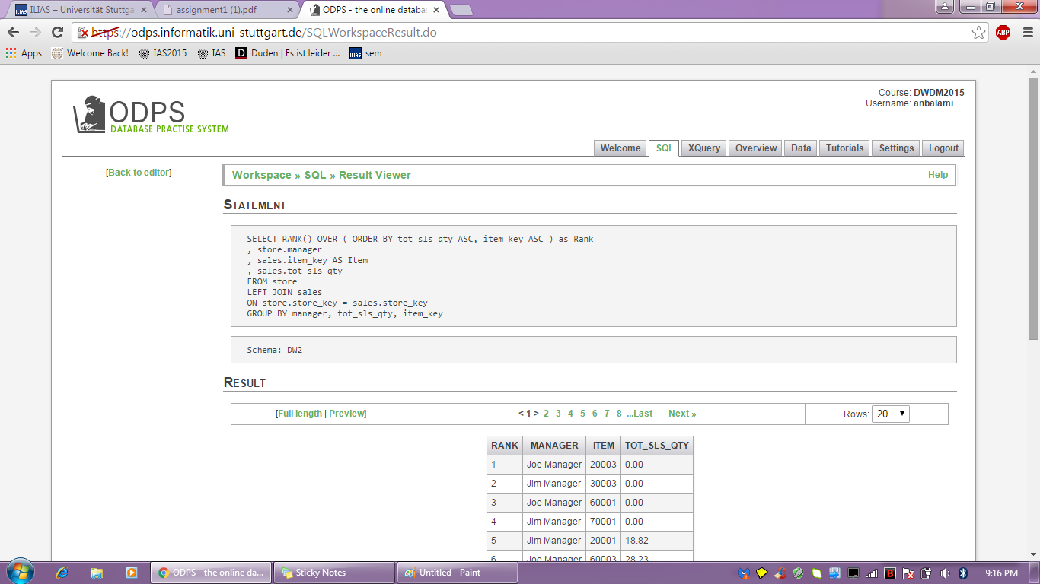

1. The SQL statement or the sequence of SQL statements that you used to derive the result table

SELECT RANK() OVER ( ORDER BY tot_sls_qty ASC, item_key ASC ) as Rank

, store.manager

, sales.item_key AS Item

, sales.tot_sls_qty

FROM store

LEFT JOIN sales

ON store.store_key = sales.store_key

GROUP BY manager, tot_sls_qty, item_key

1. A short explanation on the idea behind the queries

SELECT RANK() OVER ( ORDER BY tot_sls_qty ASC, item_key ASC ) as Rank

, store.manager

, sales.item_key AS Item

, sales.tot_sls_qty

The above line selects the Manager, Item, Tot_sls_qty and the ranking based on the tot_sls_qty.

FROM store

LEFT JOIN sales

The above line selects the respective values explained before from the store and sales table with a left join.

ON store.store_key = sales.store_key

GROUP BY manager, tot_sls_qty, item_key

The above line joins the before mentioned tables using their primary key (store_key) and groups by the manager, tot_sls_qty and the item_key.